PIPE FAILURE PREDICTION MODEL.
-- I want to do a pipe failure prediction using the data set I already have.
-- I will find relationships between the target variable and the other variables to know what characteristics are associated with pipes that actually fail. This will be the BIVARIATE ANALYSIS.
-- We are trying to get the best variables/columns that the machine learning model will use to make future predictions.
-- Our TARGET VARIABLE will be failure_within_90_days where 1 = failure and 0 = non-failure
-- IN Bivariate analysis, one variable compared with the target does NOT yet prove that it is inherently safer/better/predominant than another variable.
-- Other factors could be influencing the results — for example, in this case, pipe age, operating pressure, diameter, soil conditions, maintenance history, rainfall, or where each material is used.
-- That's actually a good lead-in to your multivariate analysis/modeling: the ML model can determine whether one variable still contributes to failure prediction after accounting for the other variables.
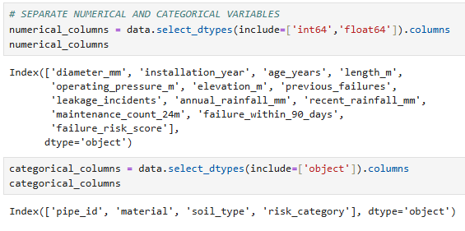
VARIABLE | BIVARIATE ANALYSIS WITH THE TARGET
diameter_mm | -- Do pipes with smaller diameter fail more often than pipes with larger diameters?  -- Between larger and smaller diameter pipes, which one has the highest probability of failure?  -- Which pipe diameter is likely to fail within 90 days?  -- Do pipe diameter and failure rate have a negative correlation? The smaller the diameter, the higher the failure rate)
Installation_year | -- Between pipes installed years ago and pipes installed recently, which ones have a higher failure rate?
Age_years | -- Does pipe age_ years and failure rate have a positive correlation relationship?(The higher the pipe age, the higher the failure rate).
Length_m | -- Do longer pipe lengths have a higher or lower failure rate?
Operating_pressure_m | -- Do pipes with a high operating pressure have a higher failure rate?
Leakage_incidents | -- Do pipes with high leakage incidents have a high failure rate?
Annual_rainfall_mm | -- Do pipes receiving waters from areas with high annual rainfall have a high failure rate?  -- Does a high annual rainfall amount cause a high failure rate?
Recent_rainfall_mm | -- Does a high recent rainfall amount cause a high failure rate?
material | -- Does one pipe material have a higher failure rate than another material?
Soil_type | -- Does the soil type around the pipeline contribute to a higher or lower failure rate?
Previous_failures | -- Do pipes with previous failures have a high probability of failing again in the future?
Maintenance_count_24m

PIPE DIAMETER FAILURE RATE

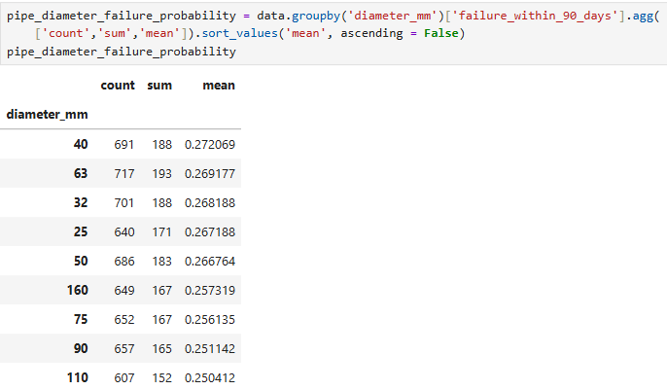
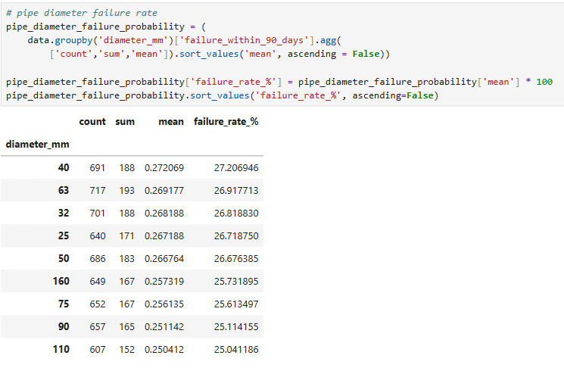

-- All the pipe diameters have a failure rate of between 25% and 27.2%. Smaller diameter pipes(40mm, 63mm. 32mm, 25mm and 50mm) have slightly a higher failure count and failure rate.

PIPE INSTALLATION YEAR FAILURE RATE

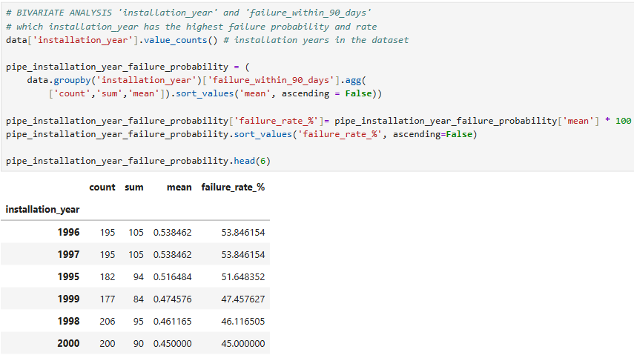
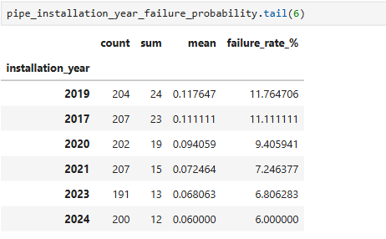
-- Pipes installed years ago have a high failure rate while pipes installed recently have a lower failure.

PIPE AGE YEAR FAILURE RATE

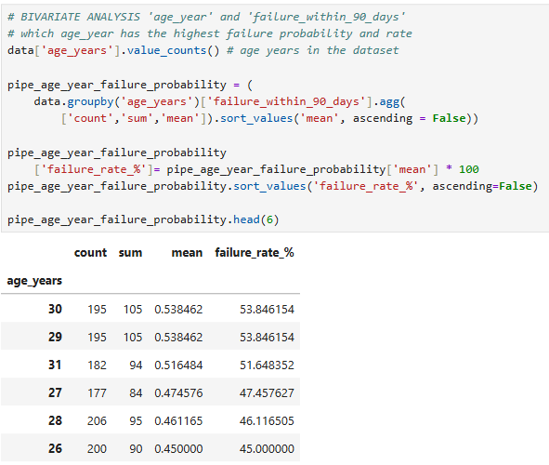
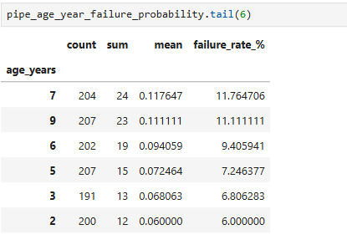
-- Pipes with a high age have a high failure rate and pipes with a lower age have a lower failure rate(positive correlation)
PIPE LENGTH(m) FAILURE RATE

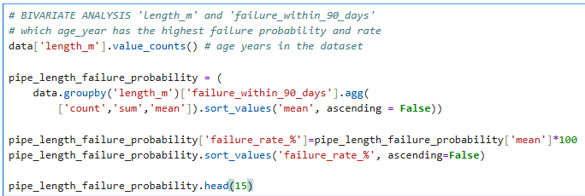
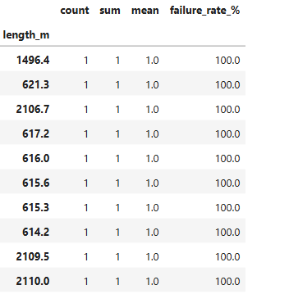
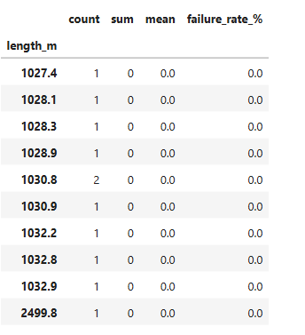

-- Most shorter pipe lengths have a higher failure rate while most longer pipe lengths have a lower failure rate.

PIPE OPERATING PRESSURE(M)
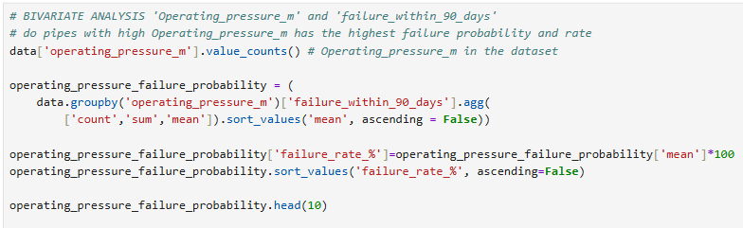
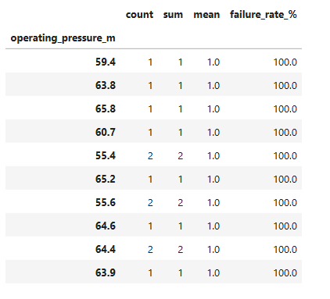
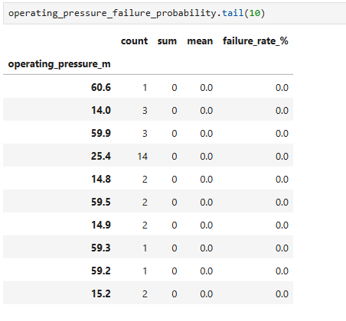

-- Most pipes with a high operating pressure have a high failure rate and most pipes with low operating pressure have a lower failure rate(positive correlation)
LEAKAGE INCIDENTS.
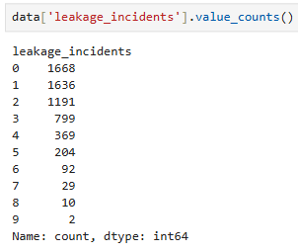
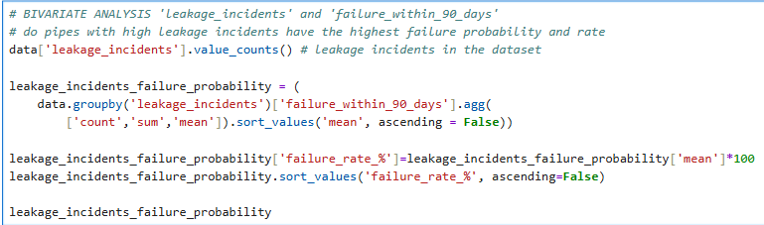
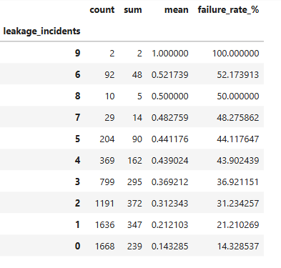

-- Pipes with high leakage incidents also have high failure rates(positive correlation)

ANNUAL RAINFALL(mm)
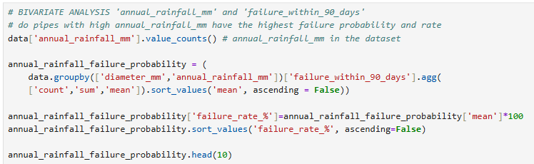
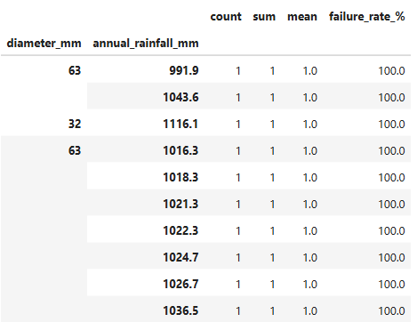
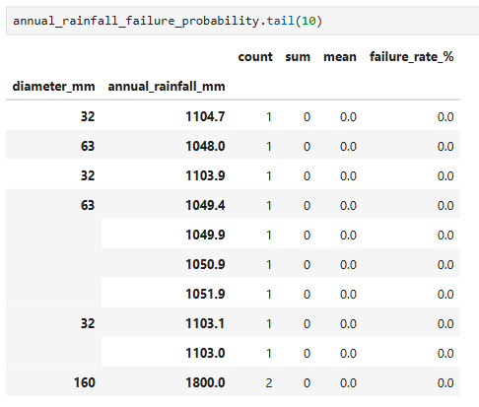

-- Annual rainfall and failure rate have no correlation. Annual rainfall itself does not determine failure rate.
RECENT RAINFALL.
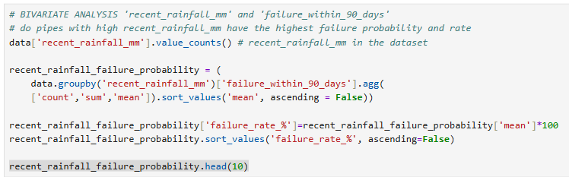
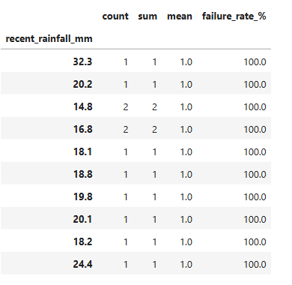
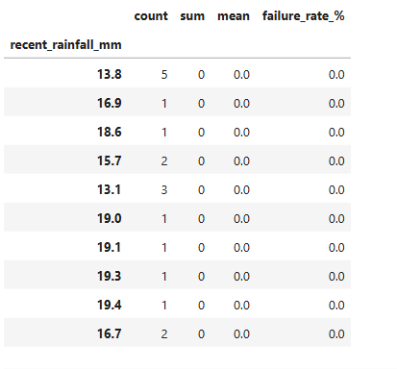

-- Pipes with slightly higher recent rainfall amounts have a higher failure rate.

PIPE MATERIAL.
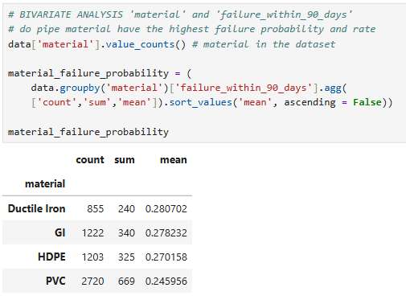

-- PVC has the highest absolute number of failures, but the lowest observed failure rate among the four materials. This is largely because PVC represents the largest number of records in the dataset. Therefore, raw failure counts alone can be misleading when comparing materials; failure rates provide a more meaningful comparison by accounting for the number of pipes/records in each material group.
-- This does NOT yet prove that PVC is inherently safer or that Ductile Iron is inherently more failure-prone. Other factors could be influencing these rates — for example, pipe age, operating pressure, diameter, soil conditions, maintenance history, rainfall, or where each material is used.

SOIL TYPE.
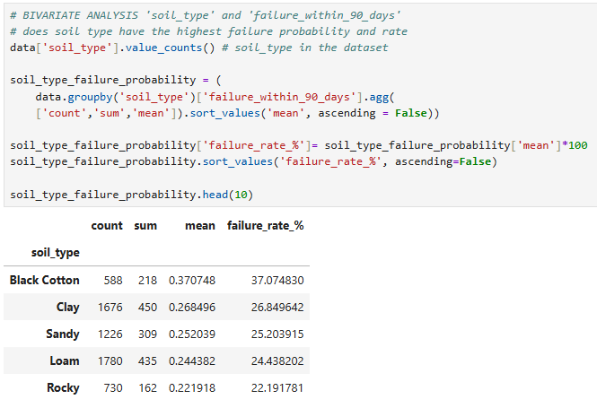

-- Pipes in black cotton soil have a high failure rate of 37.1% while pipes in rocky soils have the lowest failure rate of 22.2%

PREVIOUS FAILURES.
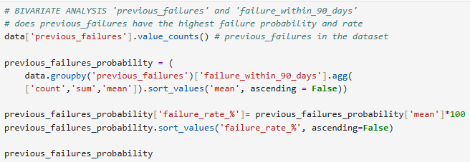
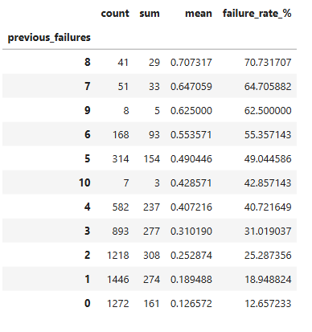

-- Pipes that have had previous failures before have a high failure rate than those with no previous failures(positive correlation)

MAINTENANCE COUNT(24m)
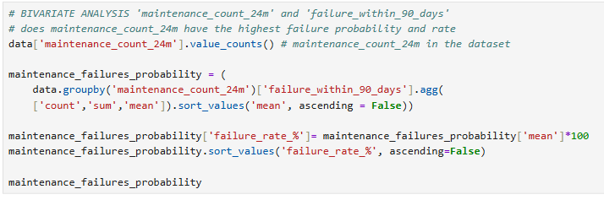
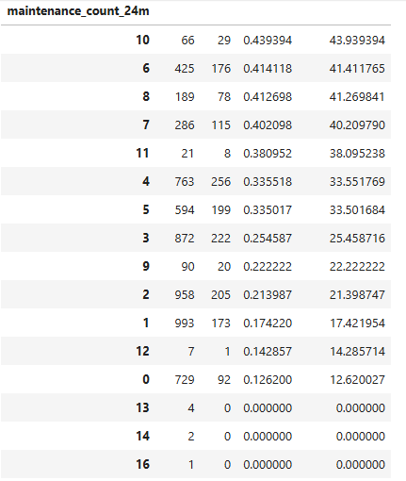

MODEL FEATURE SELECTION
-- Feature Selection is where we turn our EDA findings into a clean set of variables for the ML model.
-- But creating a feature doesn't automatically mean we should keep the original variables and every derived variable together.
-- The first thing we need to do is prevent data leakage and redundant predictors.
-- From your dataset,the target is failure_within_90_days.
-- First, we will exclude failure_risk_score and risk_category because the risk score was calculated using information related to failure_within_90_days, then giving it to the model is essentially giving the model a pre-existing prediction of the target.That creates target leakage.
-- We will also exclude installation year because it contains essentially the same information with age_years if:
age_years = current_year - installation_year
-- Age_years is more like an engineered function from the difference between the current and installation years. Always pick the final derivative.
-- You can find out overlapping variables(variables with almost the same information by doing correlation between the variables. Variables with same info will have a high positive correlation of 0.9 and above)
-- pipe_id should also be excluded because it's just an identifier and shouldn't contain predictive information.
-- The Candidate predictors/variables chosen for the model will be:
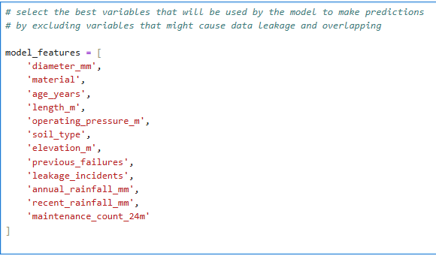

DEFINE X AND Y FOR THE MODEL
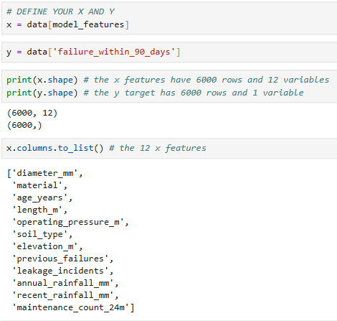

SPLIT THE MODEL FEATURES INTO TRAINING AND TESTING SETS.

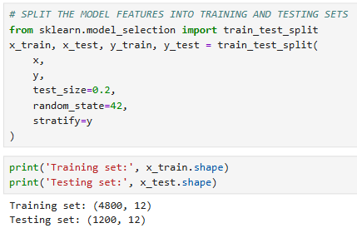

SCALE/STANDARDIZE THE NUMERICAL VARIABLES
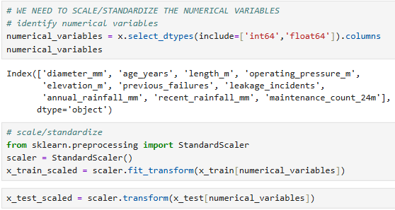

ENCODE THE CATEGORICAL VARIABLES
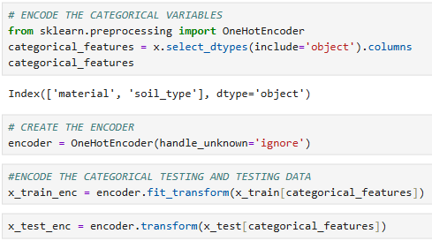

COMBINE THE SCALED AND ENCODED DATASETS
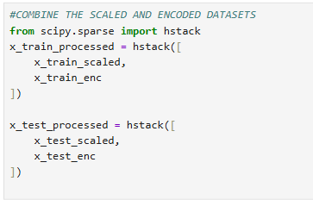

CREATE AND TRAIN THE LOGISTIC REGRESSION MODEL
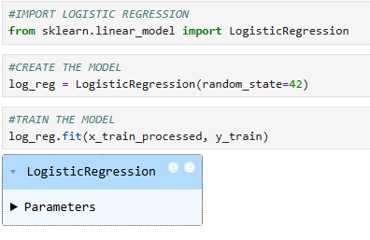

MAKE PREDICTIONS
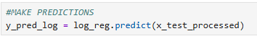

CALCULATE ACCURACY.
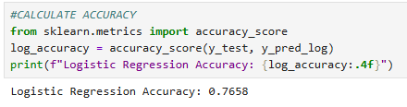

ACCURACY.
-- Accuracy answers the question: Of all the total predictions the model made(both non-failure and failure), how many of the predictions were correct.
-- The model made a total of ( 833+229) = 1062 non-failure predictions and a total of (52+86) = 138 failed predictions. These are 1200 predictions. Out of these, 833 and 86 were correct = 919 correct predictions.
-- The accuracy will become 919/1200 = 0.7658 = 76.58%.

CLASSIFICATION REPORT.
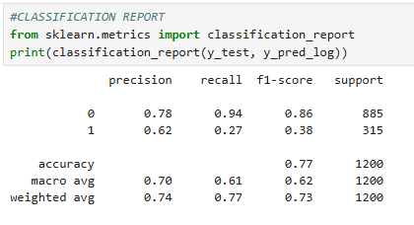

CONFUSION MATRIX
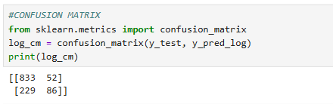

ROC-AUC SCORE.
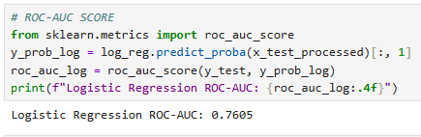

LOGISTIC REGRESSION MODEL RESULTS
-- The total number of pipes from the confusion matrix table above are (833+52+229+86) = 1200 pipes instead of the 6000 borrowers in the dataset.
-- This is because when splitting the model features, 20% of the 6000 pipes were assigned for TESTING, which is 1200 pipes.

PRECISION.
-- From the confusion matrix table above, the logistic regression model predicted 138 (52+86) failed pipes and 1062(833+229) non-failed pipes. These two columns add up to 1200 borrowers which verifies the 20% data test size.
-- Precision answers the questions: Of all the failed pipes the model predicted, how many were actually true/positive?’ and ‘Of all the non-failed pipes the model predicted, how many were actually true/positive?’.
-- Of all the failed pipes the model predicted(138), 86 pipes were actually true/positive. This gives us the class 1 precision as 86/138 = 0.6231 = 0.62 (when rounded off)
-- Of all the non-failed pipes the model predicted(1062), 833 were actually true/positive. This gives us the class 0 precision as 833/1062 = 0.7844 = 0.78(when rounded off)
-- The above two precision are backed up in the classification report.
RECALL
-- Recall answers the questions: ‘Of all the pipes that actually failed, how many did the model correctly identify?’ and ‘Of all the pipes that actually did not fail, how many did the model correctly identify?’
-- Of all the actual failed pipes/class 1 (229+86), the model correctly identified 86 failed pipes. This gives the class 1 recall as 86/315 = 0.2730 = 0.27 (when rounded off)
-- Of all the actual pipes that did not fail, the model correctly identified 833. This gives the class 0 recall as 833/885 = 0.9412 = 0.94 (when rounded off).
-- The above two precision are backed up in the classification report.

ROC-AUC
-- ROC-AUC essentially asks:“How good is my model at ranking actual failed pipes above non-failed pipes across different thresholds?”
-- This is probably the most encouraging result from this first model.
ROC-AUC = 0.7808. A ROC-AUC of 0.7605 means the model has a fairly good ability to distinguish between failed and non-failed.
-- If you randomly choose one failed and one non-failed, your model will rank the failed as having a higher failure risk about 78.1% of the time.

TEST SEVERAL THRESHOLDS
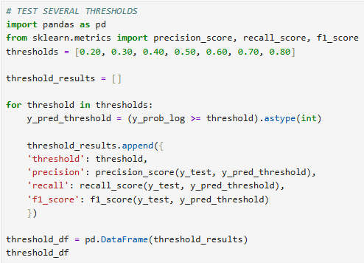
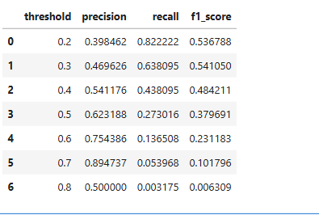

LOWER THRESHOLD
-- When the threshold is lower, the precision also becomes low while the recall increases.
-- Remember, precision answers ‘Of all the pipes the model predicted would fail
, how many actually failed?’ and recall answers the question ‘Of all the pipes that actually failed, how many did the model identify?’
-- The original precision was Of all the pipes the model predicted would fail(52 + 86 = 138), how many pipes actually failed(86) = 86 / 138 = 0.623 = 62.3%. This was when the default threshold was 0.50
-- The original recall was ‘Of all the pipes that actually failed(229 + 86 = 315), how many did the model identify(86)?’= 86 / 315 = 0.273 = 27.3%. This was when the default threshold was 0.50
-- Now when the threshold is lowered to 0.20, the precision is also lowered to 0.398 = 39.8% and the recall increases to 0.822 = 82.2%
-- This means at a lower threshold, the model predicts a lower number of pipes that actually failed (39.85 compared to the original 62.3%) and predicts more pipes would fail but actually did not fail.
-- It also means of all the pipes that actually failed, the model identified a higher number of the( 82.2%) compared to the original (27 .8%)
-- The opposite is true when the threshold is high

FIND THE THRESHOLD WITH THE HIGHEST F1
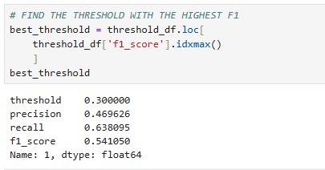

VISUALIZE THE TRADE-OFF
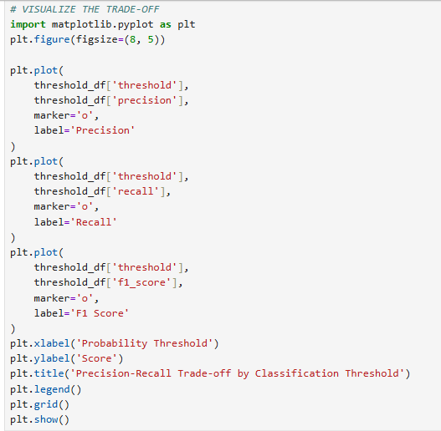
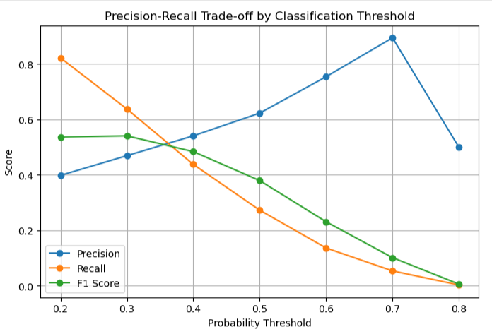

CONCLUSION.
-- ROC-AUC = 0.7605. A ROC-AUC of 0.761 means the model has a fairly good ability to distinguish between pipes that will fail and those that won’t fail.
-- If you randomly chose two pipes, the model will rank the failed pipe as having a higher failure risk about 76.1% of the time.

-- Best Threshold
-- 0.30 produced the highest F1 among the tested thresholds.
-- So lowering the threshold from 0.50 to 0.30:
- decreased precision from 62.3% → 47.0%
- increased recall from 27.3% → 63.8%
- increased F1 from 38.0% → 54.1%

